Ch1

Questions:
What 2 subsystems do we want to break it up?
- Directory management/ Listing services
- Rating and ranking/ Match making

What primary areas do we want to focus on?
How will the system work?
How each use case works?
How it will be built?
How will the components that will solve the problem?

Ch2

Who are the stakeholders?

There is no fundraisers or big stakeholders on The Institute of Mindfulness, but to fundraise and seek donations or business partners to put the money to just the basic needs of the website.

Stakeholders:

Internal: anyone directly involved with the business. For example each group of mindfulness.

External: Suppliers, Creditors, customers
- This would include anyone that subscribes or buys off of us through the website.

Operational:

Executive:

What are the primary functional requirements for the system?

- link practitioners together in communities.
- provide listings for organizations
- provide rating services
- Match services wanted with services offered

what are the primary Non-Functional requirements for the system?

-Visually pleasing
- safe and secure
- quick to load and operate

What technology and communication requirements do you see?

-Directory management
-Search Capabilities
- Match making

Ch4

- List the domain classes and their attributes that should be included in the directory subsystem?

Class: Customer Attributes: Customer number, name, bill address, home phone

Class: General practices Attributes: Noun Description, Description (Example: Creative, Movement.)

Class: Service Attributes: Title, Time Held, Description, Instructor, Benefits (example: Yoga, Dance, Meditation)

- Using the noun technique what are all the nouns that are important to directory?
- Services
- Community
- Rating
- Organization
- Events
- Customer
- Confirmation
- Services wanted

- Create a Domain Model class for one of your services in directory?

Customer
custName
custNum
billAddress
homePhone

Practices
pracNoun
pracDescription

Service
title
timeHeld
description
instructor
benefits

1 0…*

Ch 5

- Make a state machine diagram for finding a service in directory

Can’t find service Please try again

Get service Request
Sign up for Mindfulness Service
Is the Service Available?
Idle

- Create an SSD for rating services
System

Prompt rating
Enter Service your rating
Description, Average rating, Reviews
Give rating

CH6

What aspect of design becomes extremely important to protect the integrity of the system?

- The integrity of a database is enforced through a User Access Control system that defines permissions for who can access which data.
- No person other than mindfulness administrators should have direct access to data for input or change.
- The database servers should reside on a secure segment of the network behind the firewall
- It should be set that the user logs into the application server and not database with the applications server of mindfulness having the credentials to go to the database.

2. Develop a network diagram showing how all the equipment will be connected.

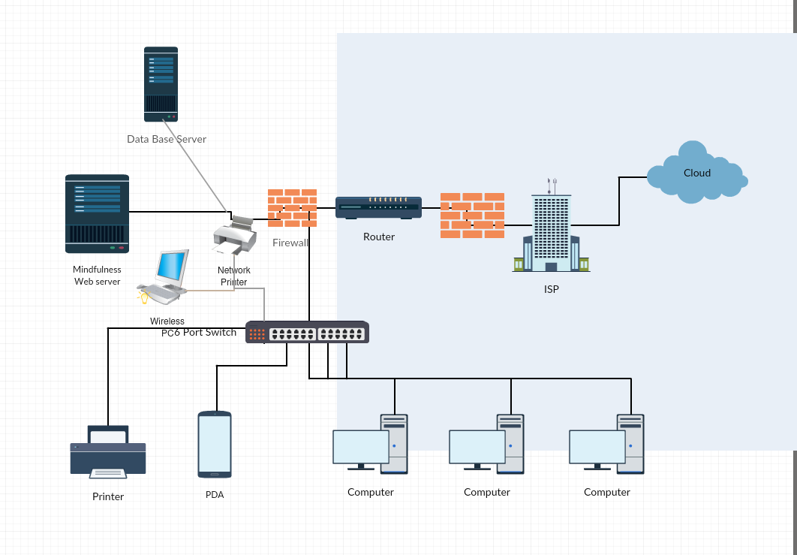

Consider the issues related to wired and wireless data transmission between servers and workstations within Mindfulness. What security duties, if any, apply to transmissions containing any sensitive information on the website?

Security of wired and wireless data transmission and hosted servers require first that the servers are hosted in a secure environment and second that all data, stored and transmitted be encrypted. Transmitted data is more complex because the encryption must be dynamic due to the remote nature of mobile devices and distributed computers. In Mindfulness we must have the physical facility and access to the servers themselves must be in a secure facility.

Ch7

Create a storyboard that shows an example of a pop-up alert and a menu of options that security might select after an alert.
Customer: I would like to find activity for me
System: here are the activities we offer
Customer: I would like to take a yoga class
System: Here are the times and when the yoga classes take place
Customer: How much would a class be
System: give me your credit information it will be this much money

Create an example of the inventory report for the application
Activity | Amount of classes | Average Cost per class
Music and singing | 56 | $129
Meditation | 78 | $70
Yoga | 20 | $119
Dance | 17 | $80
Story Telling | 32 | $99
Aikido | 24 | $86

CH8

- How long might this project take and which SDLC would be most appropriate?

I would the planning would take 3-4 weeks, the analysis takes 2-3 weeks, design would take 3 weeks and implementing the system would take another 4 weeks. I would use the Overlapping predictive SDLC due to the fact that its more flexible and can visualize and see the overlap of the phases and where we want to be.

- The SBRU information system includes four major subsystems: Resort relations, Student booking, Accounting and finance, and Social networking. Although you have only worked with the domain model class diagram for the Social networking subsystem, list as many of the domain classes that would probably be involved in each of the subsystems. Relate to our project

Practice | - Schedule  - Reminders  - FAQ  - Blog
ED | - Wiki  - Teacher  - Student
Directory | - Search  - Listings  - Rating  - Matches  - Ads  - Forums  - Conferences
Tech | - Tech support  - TechFAQ  - WebHosting  - VideoStream

- How might you use incremental development to get some core functionality or some subsystems deployed and put into use before the project is completed?

The Practice, Portal and Directory are the most critical and cold be deployed first. We don’t really need Education and Tech right away due to the fact that they can help the website but not vital for the system to start up, but do need to get done as soon as possible.

Ch9
- Create a work breakdown structure for the first iteration of the project.

Discipline | Activity | Effort
Planning | - Set a work environment  - Develop and plan work | 2 days
Analysis Activities | - Define all data  - Model user cases that work created by each sector | 3 ½ days
Design activities | - Design Screen layout  - Design Databases  - Design use case processing | 5 days
Build Activities | - Build database  - Write code  - build test data  - set up for user test  - release first use cases  - deploy application | 9 ½ days
Total Days |  | 20 days

- A related decision is whether to organize your programmers into one larger team or multiple smaller teams and how many programmers you can use on this project. Make that decision and then defend your answer

I think it be key to organize the programmers into multiple smaller teams of about 4-5 like we have our groups in now because I think it be much more effective due to the different subsystems we have. Each group that we have has its own individual purpose and is unique by itself, So having multiple groups can help make each subsystem more powerful and useful due to the number of people working on a small portion of the total project.

CH 10
- Draw a basic component diagram showing the architectural design for the system, assuming that it is a two-layer Internet architecture.
Webpage

Server
Search engine in Directory
Internet

MLSInquiryApp (used to analysis the listing services in the database of practices available)
MLSUpgradeApp (used to update the multiple list of practices)
database

2. For the moment, assume that the database will store two glucose levels for each patient—normal minimum and normal maximum—and that an alert will be generated if three or more consecutive glucose readings are above or below those levels. Expand the domain class diagram in Chapter 4 to include this information and then develop a firstcut design class diagram to support the patient use case View/respond to alert.

Classes
Time: time
Days: string
ageGroup: integer
level: string
Availability
dateTime: datetime
daysAWeek: integer
Interests
Practices: string
User
Id: integer
lastName: string
firstName: string
datOfBirth: date
username: string
password: string

Directory

Ch11

develop a separate multilayer sequence diagram that includes the domain classes and the view layer classes.

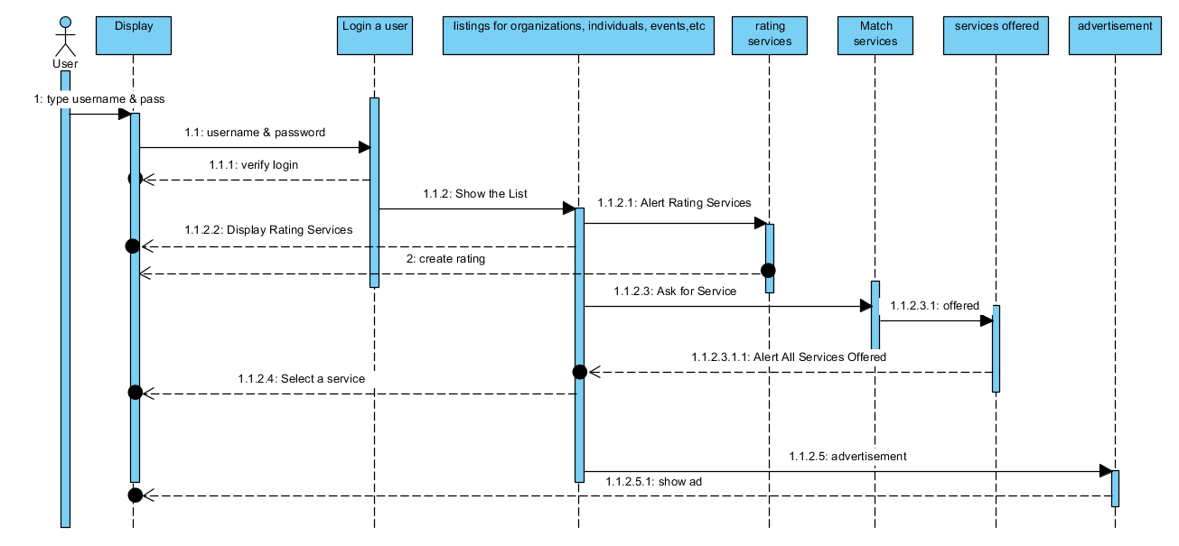
Classes
Time: time
Days: string
ageGroup: integer
level: string
Availability
dateTime: datetime
daysAWeek: integer
Interests
Practices: string
User Login
Id: integer
lastName: string
firstName: string
datOfBirth: date
username: string
password: string

Directory

Ch12

2. For each user and each type of device, discuss what security precautions and techniques should be used to protect access to the application programs, connect to the home system, and protect the data being transmitted to the foreign devices

We have to make sure Access control is in place that way unauthorized users cannot get into data they aren’t supposed to see. To do this we need to use the AAA approach. Which includes Authentication, Authorization and Access control list.
While we have to secure our application from the outside we also should from the inside because the weakest part of security in a company are insiders who have access to this data. We can do that by Separation of duties which allows multiple people reviewing work and doing this ensures that no one has sufficient system access to commit and cover up a fraud.
The applications and data in home system can be protected by the various ways. Those are file encryption technology with Asymmetric Key encryption which is more secure due to the fact the only person who knows the private key is the person who is receiving the data.
The file encryption used to encrypt the particular file, next one whole disk encryption protects the whole thing on a disk drive together with the operating system. That technology keeps exact copies of data working on as well as the temporary files also encrypted.
Then data sharing on the public networks, it brings into data loss and data theft. So, avoid these problems use Virtual Private Network (VPN). The VPN makes a tunneled network connection through the Internet which securely connects users and remote sites together.
To protect our data we need to implement redundancy, backup, and recovery procedures. Backup procedures make partial or full copies of a database to a removable storage media.

Ch13
Develop an iteration test plan (i.e., one that applies to and can be used within a subsystem iteration mini-project). Discuss which types of testing (as identified in this chapter) you would include and why. Estimate how much time will be needed for each type of test. Discuss what types of testing might be combined or scheduled with an overlap.

Iteration | Subsystem | No of use cases | Time | Activities
1. | Customer | 1 | 3 weeks
2. | Customer | 1 | 2 weeks | Begin integration testing
3. | Customer | 1 | 2 weeks | Unit and integration tests
4. | Customer | 2 | 3 weeks | Unit and integration tests
5. | Customer | 3 | 4 weeks | Unit and integration tests
6. | availableClasses | 2 | 3 weeks | Unit and integration tests
7. | availableClasses | 2 | 3 weeks | Unit and integration tests
8. | availableClasses | 3 | 4 weeks | Unit and integration tests
9. | availableClasses | 3 | 3 weeks | Unit and integration tests
10. | Integration/system test |  | 8 weeks
11. | Acceptance test |  | 12 weeks
Total |  |  | 44 weeks

Chapter 14
The chapter classified apps on portable devices as device-top, free-standing Internet, and browser based. Which type is most appropriate for the client-side portions of our system? Be sure to consider such issues as client-server communication requirements and frequency, user interface quality, and portability across devices and operation systems.
I think in our project we should create a client side software that would run on IOS and android . Reason behind creating a free0standing Internet application is because its dependable, Compatible, Efficient and fast. It doesn’t have to depend strictly on the internet an can should have no problems with cross browser support. It can also be built to run fast with little delay time.

2. Which (if any) social networking capabilities might make a useful addition to the RTGM system? Be sure to consider the HIPAA requirements described for this case at the end of Chapter 6.
I think social networking in our project is key and by having the capability for online chats with staff or instructors can really enhance the system and give feedback and help users determine exactly what they want. By having an Online chat will help give people answers to quick questions they might have about our website as a whole.

